Article Evaluation Form
Dear Reviewer:

We recommend you be as precise as possible when making your comments and suggestions.

Please bear in mind that if the paper represents many language mistakes, which make reading difficult, you are not required to correct them. You should just indicate this flaw to the author in the space for suggestions, so that s/he submits her/his paper for proofreading. Papers that are in the end recommended for publication are also checked by our editor.

Title: Haga clic o pulse aquí para escribir texto.
Received on: Haga clic aquí o pulse para escribir una fecha.
- Type of article according to Colciencias classification

☐Article based on Scientific and Technological Research: A paper that in presents in a detailed way the original result of research projects. It usually contains an introduction, methodological and theoretical frameworks, results and conclusions) | ☐Paper based on reflection: It presents the results of research on a specific topic from the point of view of the author who shows his-her analytical. Interpretative and critical attitudes and resorts to original sources
☐Revision of a Specific Field: This paper gathers, in a systematic and integrated way, the results of published or non-published research so as to account for advances and tendencies on a specific scientific field. It is characterized by a careful bibliographical revision of at least 50 references.) | ☐Case Study Report: This paper represents the results of a study on a particular situation focusing on the technical and methodological experiences. It involves as systematic review of the literature of analogous cases.
☐Pedagogical Intervention: A manuscript that presents teaching practices that have been systematized through an analytical process. It should include a clear justification, description of the context and procedures, evidence of the pedagogical intervention, results, and conclusions, supported by relevant theoretical or research perspectives. | ☐Another: Haga clic o pulse aquí para escribir texto.

- Article sections
 | YES | NO | Comment
- The title reflects the content of the paper. | ☐ | ☐ | Haga clic o pulse aquí para escribir texto.
- The abstract presents:  - The purpose and information about the content of the paper.  - A statement of conclusion.  - No more than 250 words in English. | ☐ | ☐ | Haga clic o pulse aquí para escribir texto.
- The keywords:  - Represent the content of the article (max. 10 keywords)  - Are specific to the field. | ☐ | ☐ | Haga clic o pulse aquí para escribir texto.
- The introduction:  - Presents/ locates the topic clearly.  - Narrows down the topic effectively.  - Present the purpose and relevance of the paper. | ☐ | ☐ | Haga clic o pulse aquí para escribir texto.
- The different sections of the paper:  - Are closely related with the type of article.  - Present an acceptable organization.  - Account for the purpose of the paper. | ☐ | ☐ | Haga clic o pulse aquí para escribir texto.
- The content in the sections of the paper:  - Is coherent through the sections.  - Provides theoretical background (global and local)  - Provides wider significance of the results, review, or reflections to the fields.  - Shows evidence of results. | ☐ | ☐
- The concluding section (also a discussion)  - Addresses the broader issues of the paper.  - Emphasizes the significance of the results, review, or reflections to the field. | ☐ | ☐
- The writing style is clear:  - Use of language and punctuation. | ☐ | ☐ | Haga clic o pulse aquí para escribir texto.
- The figures or tables:  - Are all necessary and consistent. | ☐ | ☐ | Haga clic o pulse aquí para escribir texto.
- The in-text citations:  - Are efficiently integrated into the content of the text.  - All appear in the reference list. | ☐ | ☐ | Haga clic o pulse aquí para escribir texto.
- The reference list:  - Provides the information necessary to locate any source cited in the paper.  - Each entry is cited in the text. | ☐ | ☐

- Reviewer’s Concept
In your opinion the article should be:
☐Accepted | ☐Accepted after minor revision
☐Revised and Resubmitted | ☐Rejected

Why ? Haga clic o pulse aquí para escribir texto.

Suggestion (if there are some) Haga clic o pulse aquí para escribir texto.

Yours respectfully,
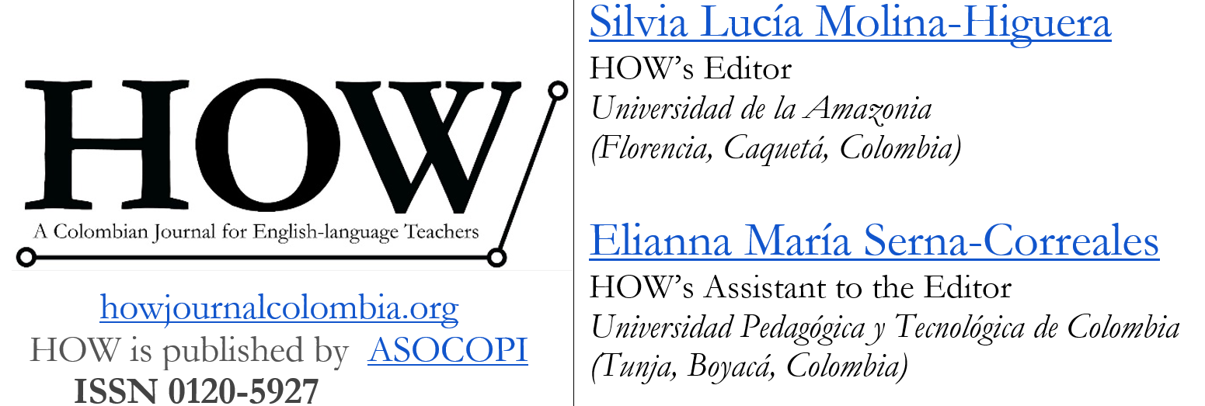

Colciencias in the governmental institution that regulates and promotes research in Colombia: https://www.colciencias.gov.co/

